Launch Jenkins from official image
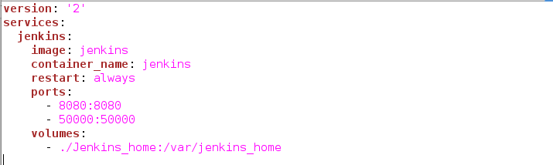
sudo docker-compose up -d
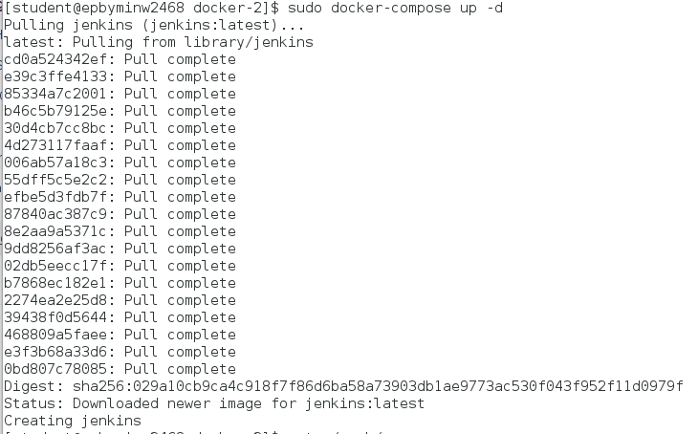

Link Docker host as a Jenkins slave

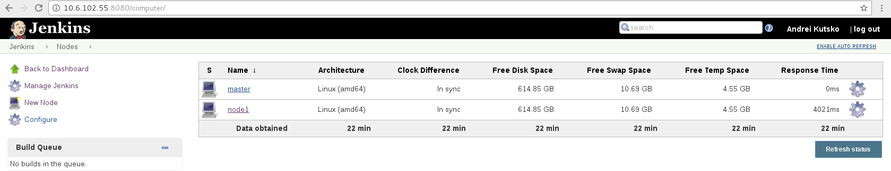
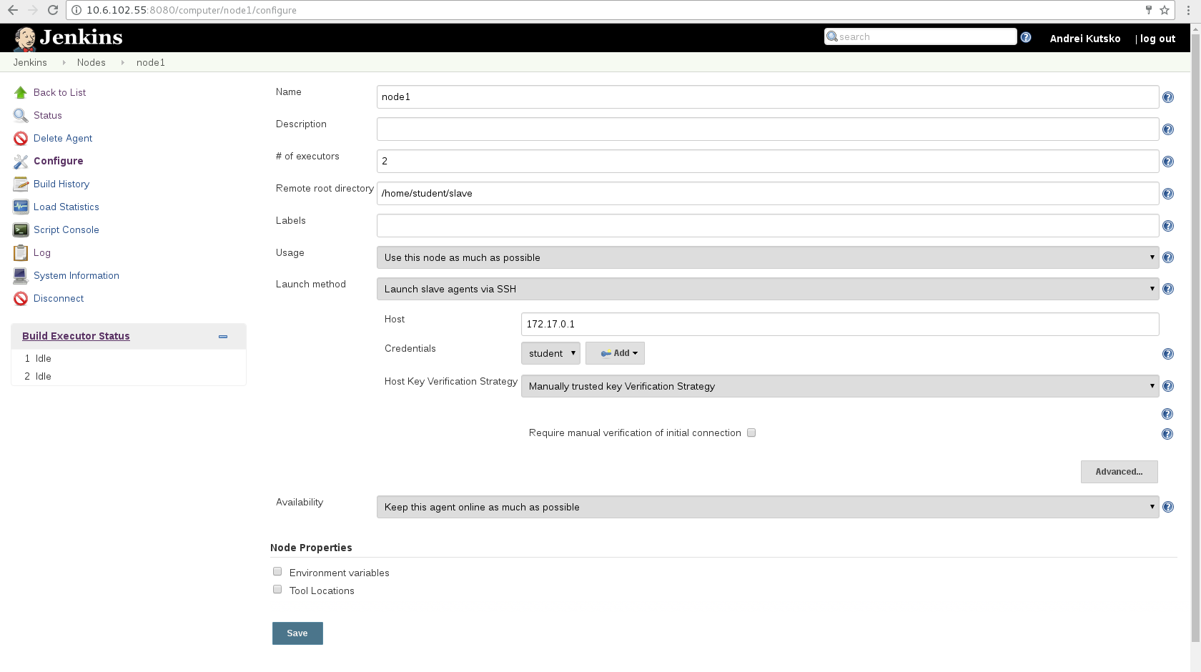
Create custom gradle image

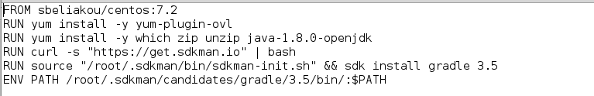

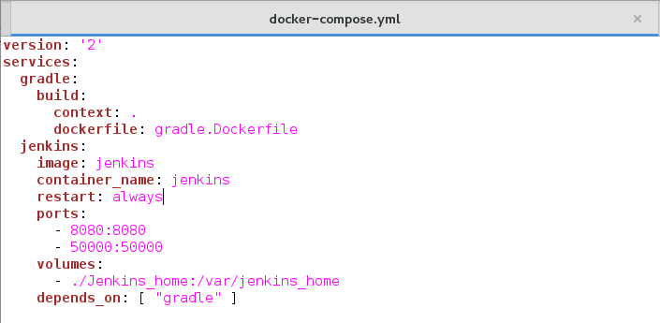

Configure a job to build spring-boot

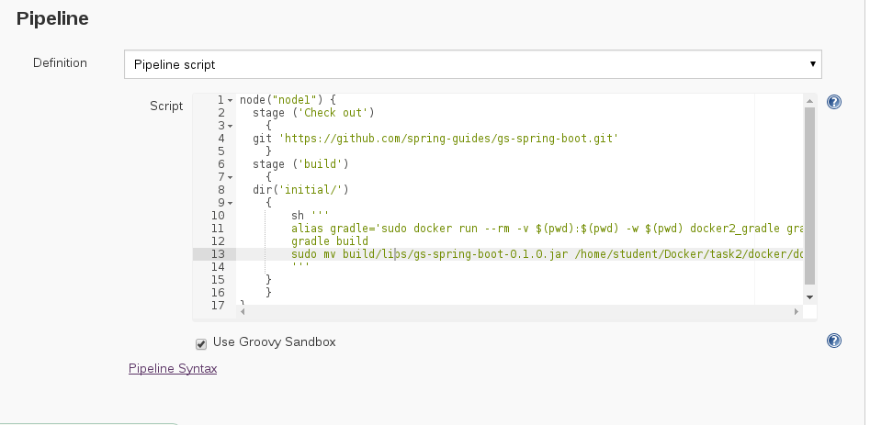
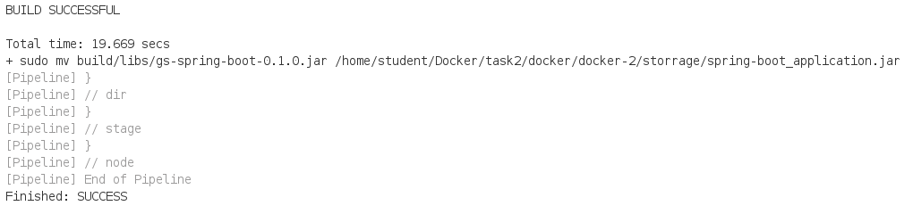
Configure a job to run spring-boot with docker -compose
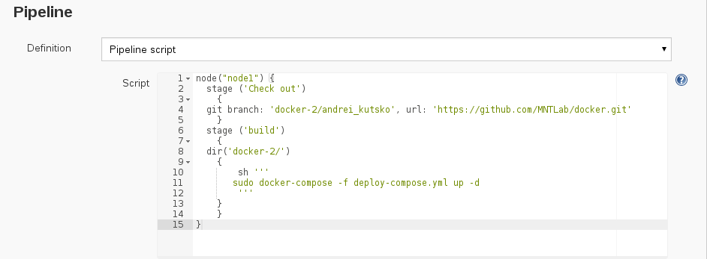

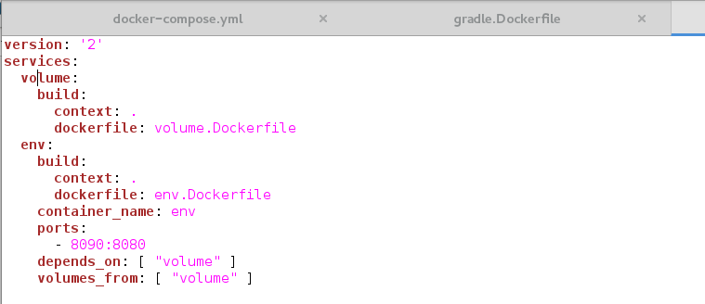
volume.Dockerfile
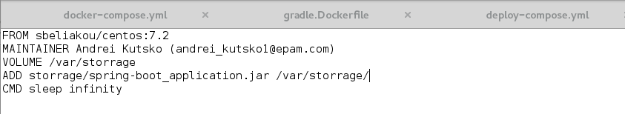
env.Dockerfile
